**<Project 1>**

21

**BLACK JACK**

CSC 5 45562

Juan Carlos Almaraz

07/21/17

**Introduction:**

This game is called Blackjack and consist of a deck of cards being used to get a total of 21. The dealer initiates the game by asking the player at the Casino Carlos if he would like to play. Once the game starts the player is given two cards and so is the dealer. The player must total the cards to 21 and decided, if another card is needed. The player can choose as many cards needed to get to 21. Depending on the amount on the cards the player decided to “stay” or “hit’. The player must decide, if the cards the dealer has are lower than his. If they are not then he must hit to beat the dealer by hitting for another card without going over 21. The dealer must hit on soft 17 and lower. So, a player must keep this in mind when deciding to take the next card to try and beat the dealer.

**Summary:**

Project size: 120+ lines

Number of variables: 32

Number of methods: 14

In this game, I took a well-known card game Blackjack and coded it. My purpose for this game was to give it the casino feel, but with a computer. I need to implement a loop to get the cards to repeat with providing more lines of code. Once this is figured out the game will be complete. My goal is to add a user screen that reflects, card designs, color, word art, and maybe some real slot machine noises.

I used some coding from the text book to recall some concepts during the process of my project. It was difficult and I had to reference some other games along with the teachers to get a start on my project. I did not know how to approach it. Once, I saw the teacher examples it was a lot easier to continue progress. Once, I got started I did what worked for me in my coding recalling as much coding concepts as I could. During the process, I had to drop some required concepts, as it was taking me longer to complete the project, due to more complications and wasted time due to no solutions.

**Variables:**

ifstream inputFile;

int number;

number = 21;

//declare variables

int houseCard;

int dealer;

int playerCard;

char yes;

char y;

char hit;

char stay;

srand (static_cast<unsigned int>(time(0)));

int card1 = rand()%11+1;

int card2 = rand()%11+1;

int card3 = rand()%11+1;

int card4 = rand()%11+1;

int card5 = rand()%11+1;

int total;

// to show the sign 21

inputFile.open("numbers.txt");

playerCard = card1 + card2 ;

card1 = rand()%11+1;

card2 = rand()%11+1;

card3 = rand()%11+1;

card4 = rand()%11+1;

card5 = rand()%11+1;

dealer = card1 + card2;

char s = 'A'; stay = 'A';

char h = 'B';

hit = 'B';

total = playerCard + card3;

houseCard = dealer + card3;

**Pseudo Code:**

*Initialize*

*Input a file*

*If file has an error display message*

*Else*

*While input file number with graphic and number*

*When the yes button is pressed*

*Deal two card to player and dealer*

*If yes*

*display two random cards between the numbers of 1-10*

*while the cards are under the correct amount*

*display message to stay or hit*

*if hit*

*display card total*

*if stay*

*display new random card*

*display player total*

*display dealer total*

*if dealer has cards of 17 and under*

*deal one more card*

*repeat until over 17*

*If the player beats dealer*

*Display winning message*

*Else If house cards beat the player*

*Display winning message*

*If cards are over 21*

*Display busted message*

**Flowchart:**

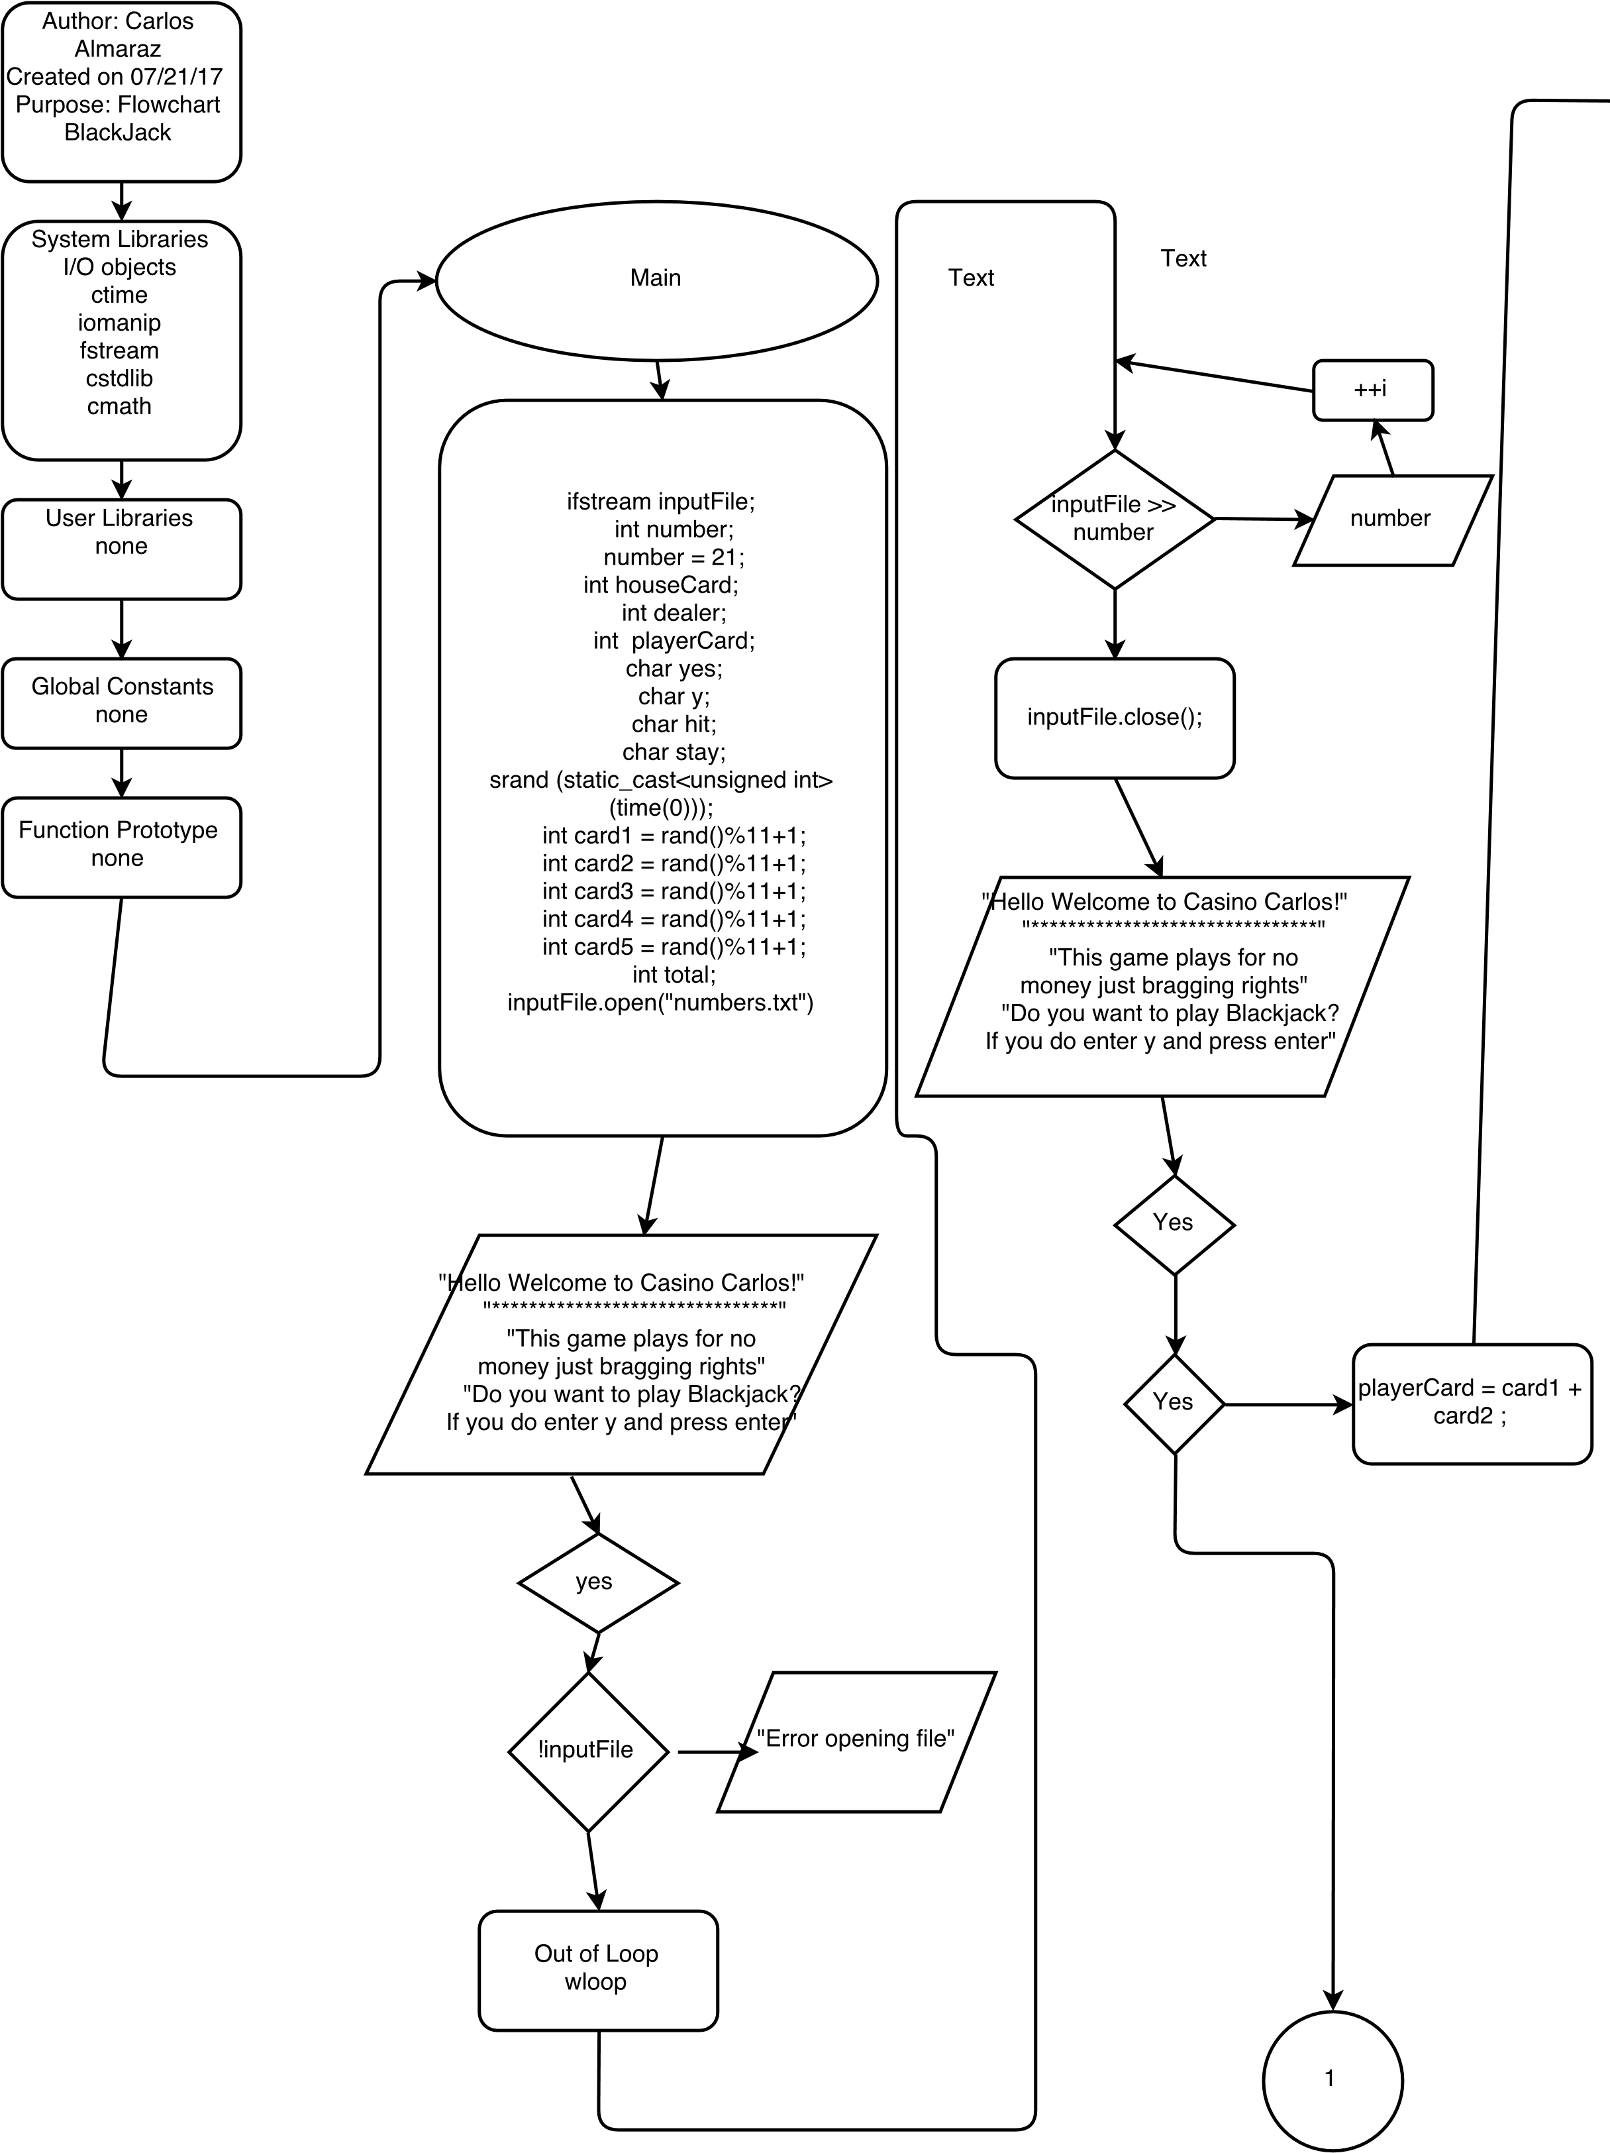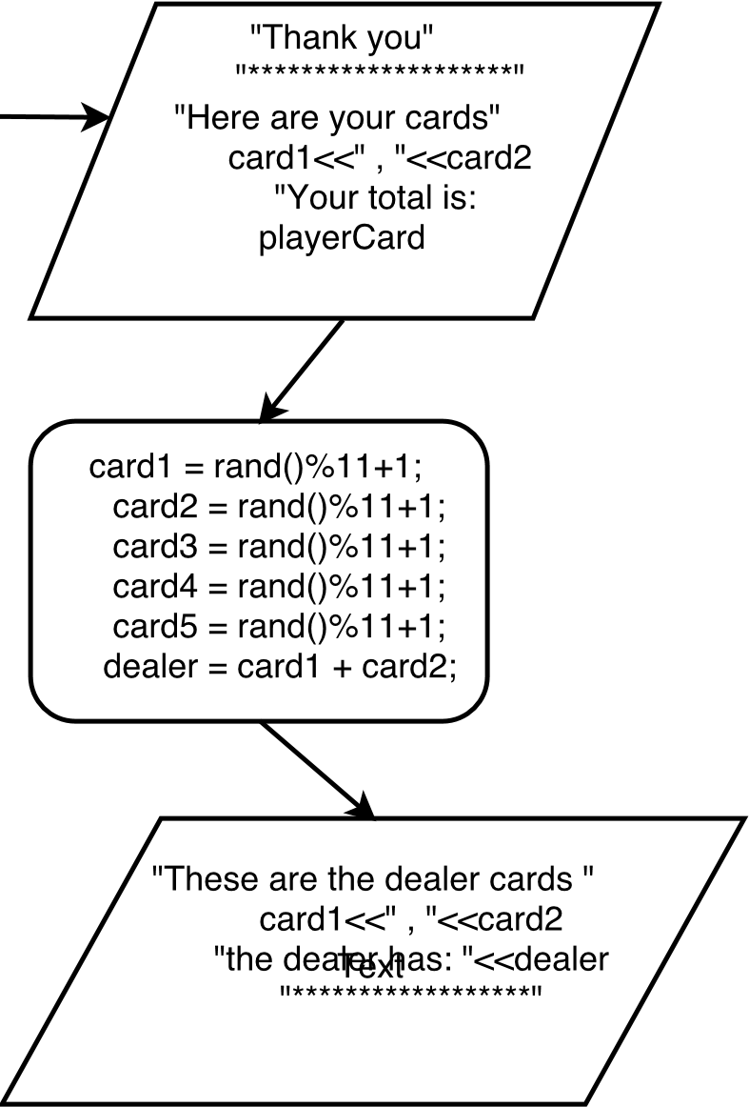

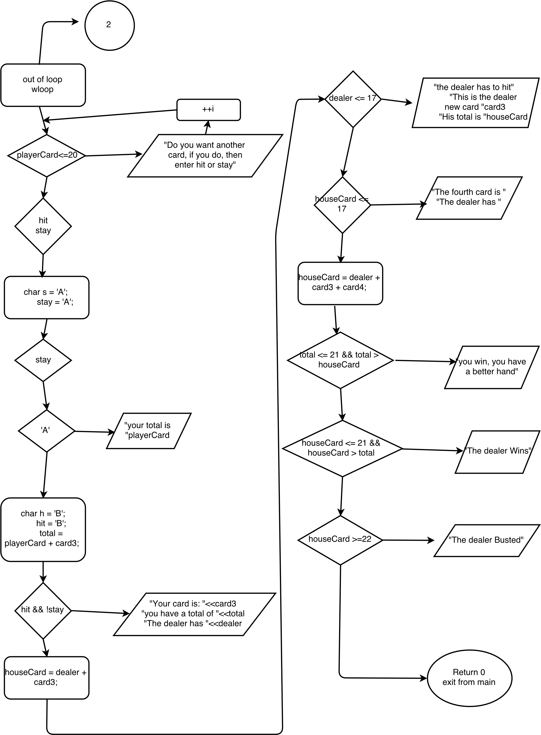

**Code:**

**/\***

**\* File: main.cpp**

**\* Author: Carlos**

**\*Blackjack**

**\*/**

**#include <cstdlib>**

**#include <iostream>**

**#include <cmath>**

**#include <iomanip>**

**#include <ctime>**

**#include <fstream>**

**using namespace std;**

**int main(int argc, char** argv)**

**{**

**// to pull up a file that has the number 21 with a big font as a sign on the table**

**ifstream inputFile;**

**int number;**

**number = 21;**

**//declare variables**

**int houseCard;**

**int dealer;**

**int playerCard;**

**char yes;**

**char y;**

**char hit;**

**char stay;**

**// to produce a random number under 11, which is 1-10 and ace**

**srand (static_cast<unsigned int>(time(0)));**

**int card1 = rand()%11+1;**

**int card2 = rand()%11+1;**

**int card3 = rand()%11+1;**

**int card4 = rand()%11+1;**

**int card5 = rand()%11+1;**

**int total;**

**// to show the sign 21**

**inputFile.open("numbers.txt");**

**if (!inputFile)**

**cout <<"Error opening file"<<endl;**

**else**

**{**

**while (inputFile >> number)**

**{**

**cout <<number << endl;**

**}**

**inputFile.close();**

**}**

**// the greeting for the game acting as a dealer**

**cout<<"Hello Welcome to Casino Carlos!"<<endl;**

**cout<<"*******************************"<<endl;**

**cout <<"This game plays for no money just bragging rights"<<endl;**

**cout<<"Do you want to play Blackjack? If you do enter y and press enter"<<endl;**

**cin>>yes;**

**if (yes)**

**{**

**// formula to add card results**

**playerCard = card1 + card2 ;**

**cout <<"Thank you"<<endl;**

**cout <<"********************"<<endl;**

**cout <<"Here are your cards" <<endl;**

**cout <<card1<<" , "<<card2<<endl;**

**cout <<"Your total is: "<<playerCard<<endl;**

**cout<<endl;**

**// to produce a random card for dealer**

**card1 = rand()%11+1;**

**card2 = rand()%11+1;**

**card3 = rand()%11+1;**

**card4 = rand()%11+1;**

**card5 = rand()%11+1;**

**dealer = card1 + card2;**

**cout <<"These are the dealer cards "<<endl;**

**cout <<card1<<" , "<<card2<<endl;**

**cout <<"the dealer has: "<<dealer<<endl;**

**cout <<"******************"<<endl;**

**cout<<endl;**

**}**

**// if cards are less than 20 it asks to hit because 21 is winning**

**while (playerCard<=20)**

**{**

**cout <<"Do you want another card, if you do, then enter hit or stay"<<endl;**

**break;**

**}**

**cin >>hit;**

**cin >>stay;**

**// this is if the person decides to stay, it shows their result and the**

**//dealer continues hand until end result**

**char s = 'A';**

**stay = 'A';**

**switch (stay)**

**{**

**case 'A':cout <<"your total is "<<playerCard<<endl;**

**break;**

**}**

**char h = 'B';**

**hit = 'B';**

**total = playerCard + card3;**

**// if the person hits it gives them another card**

**if (hit && !stay)**

**cout <<"Your card is: "<<card3<<endl;**

**{**

**cout <<"you have a total of "<<total<<endl;**

**cout <<"The dealer has "<<dealer<<endl;**

**}**

**// this automatically hits the dealer if it has 17 or below**

**houseCard = dealer + card3;**

**if (dealer <= 17)**

**{**

**cout <<"the dealer has to hit"<<endl;**

**cout <<"This is the dealer new card "<<card3<<endl;**

**cout <<"His total is "<<houseCard<<endl;**

**if (houseCard <= 17)**

**cout <<"The fourth card is "<<card4<<endl;**

**houseCard = dealer + card3 + card4;**

**cout << "The dealer has "<<houseCard<<endl;**

**}**

**// to determine who won the card game**

**if (total <= 21 && total > houseCard)**

**cout << "you win, you have a better hand"<<endl;**

**else if (houseCard <= 21 && houseCard > total);**

**cout <<"The dealer Wins"<<endl;**

**if (houseCard >=22)**

**cout <<"The dealer Busted"<<endl;**

**cout <<endl;**

**// to go to the next hand, should be a loop, but I cant get it**

**cout<<" Welcome again to Casino Carlos!"<<endl;**

**cout<<"*******************************"<<endl;**

**cout <<"This game plays for no money just bragging rights"<<endl;**

**cout<<"Do you want to play Blackjack? If you do enter y and press enter"<<endl;**

**cin>>yes;**

**return 0;**

**}**

**Concepts I will probably use and learn:**

I will have to recall how to do a loop do finish this game. I will also need to create a separate file to input the 21 sign with graphics. I will also need to add a user interface with colors and graphics, If I decided to pursue this game further.